**ASE LAB ASSIGNMENT 3**

**LOGIN PAGE**

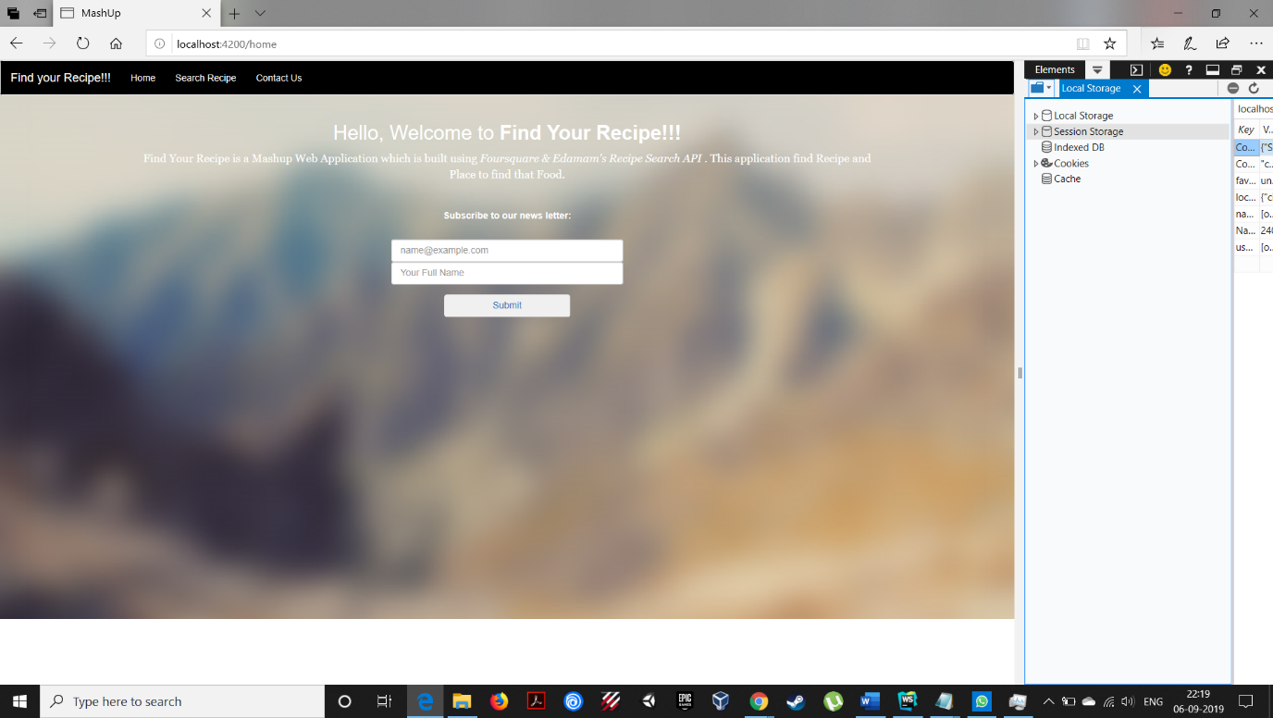

In creating the login page I have used the same style that is present in the given code. This how the login page look like.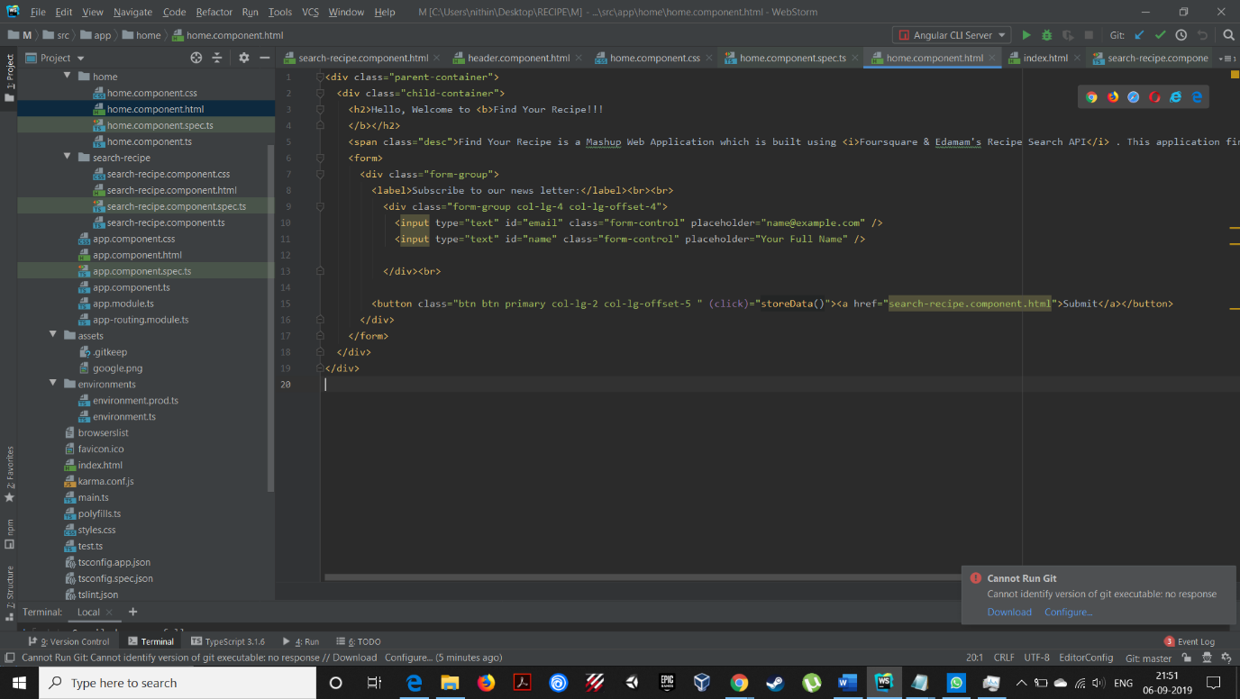

This is code for the login page. Created in the same component which was given to us.

**LocalStorage**

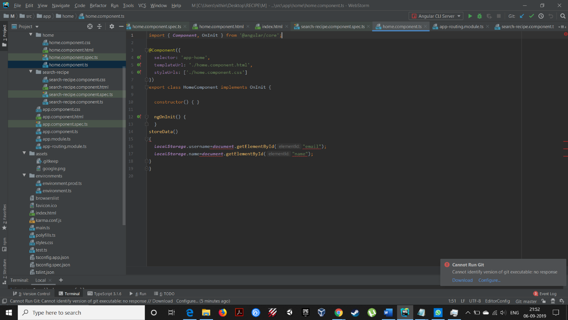

In order to store the data in local storage I have used getElementById to store the values in terms of object inorder to maintain privacy.

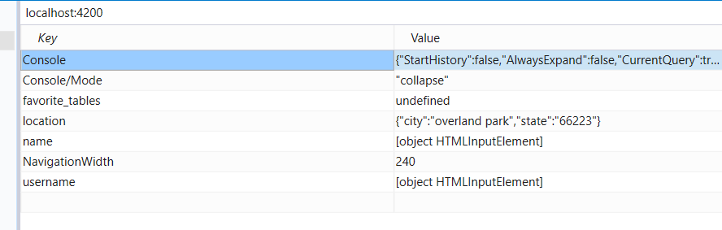

This is how my data looks in the local Storage. It is maintaining the privacy of by not showing the real data value.

**Nutrition Box**

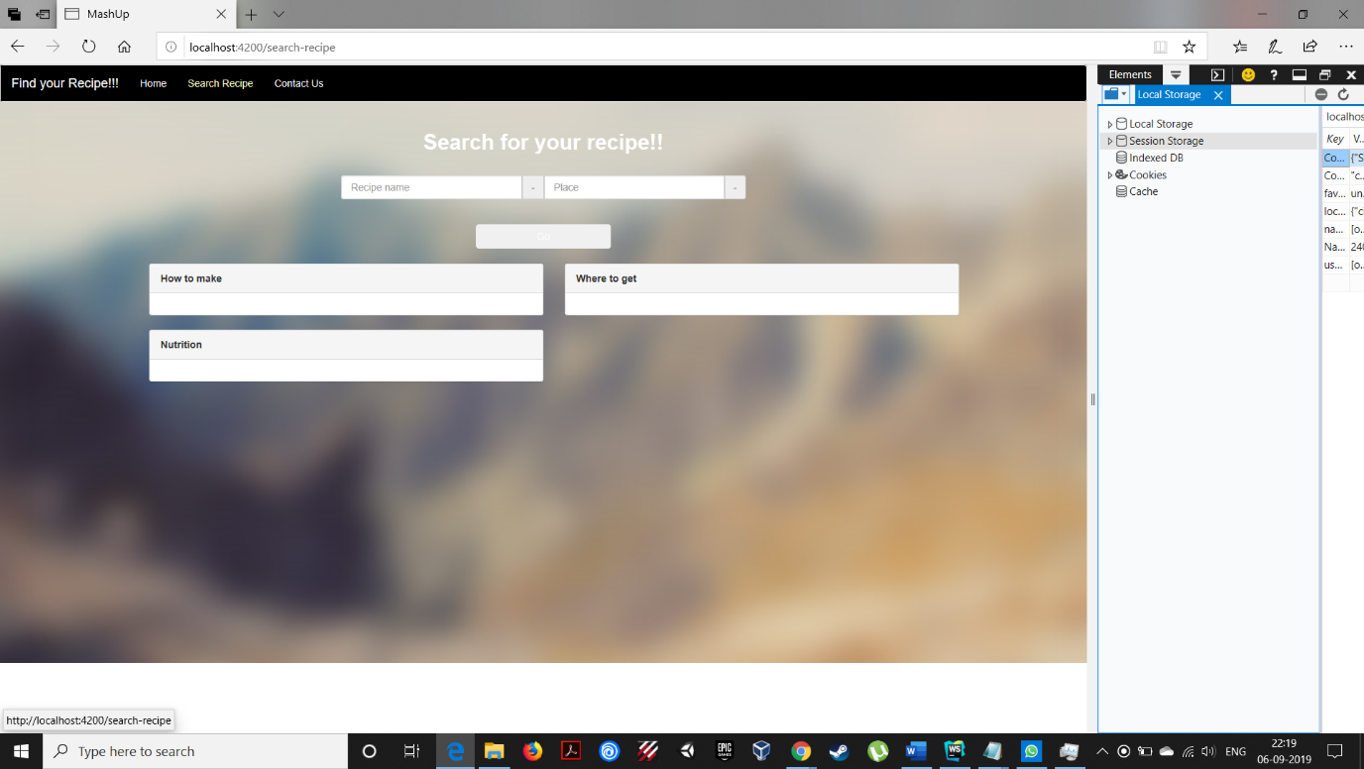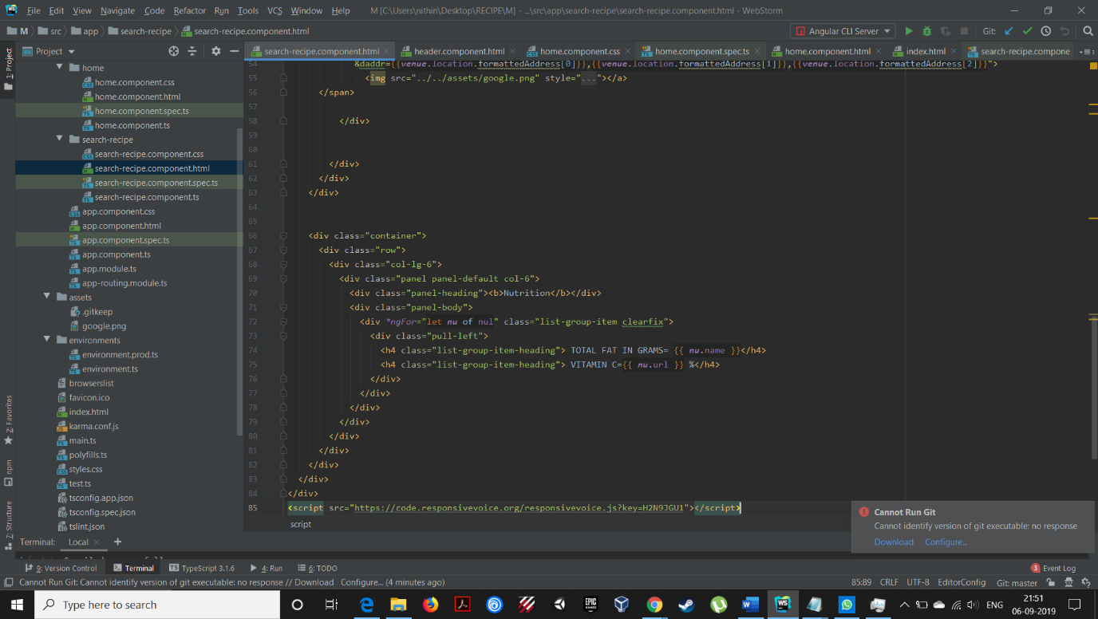

In order to maintain the Style of the page I have used the same bootstrap class for nutrition box.

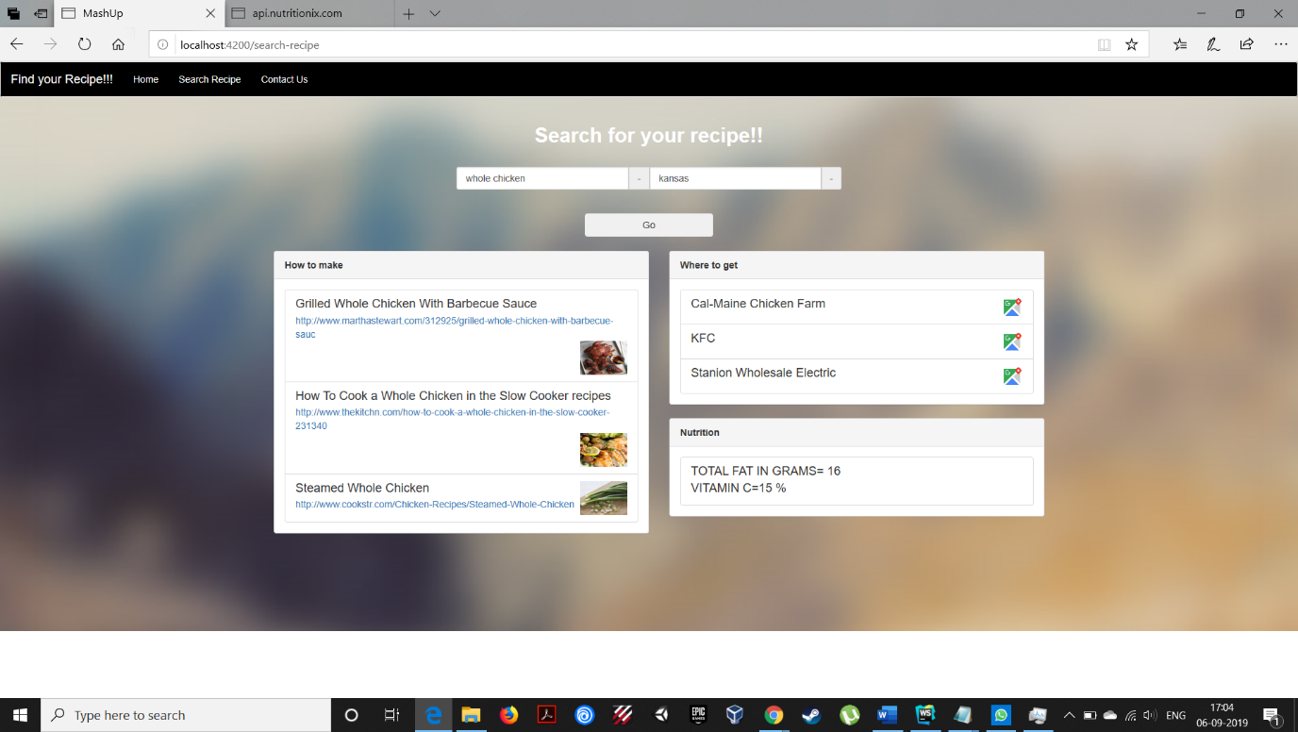

This is the final output of the page.

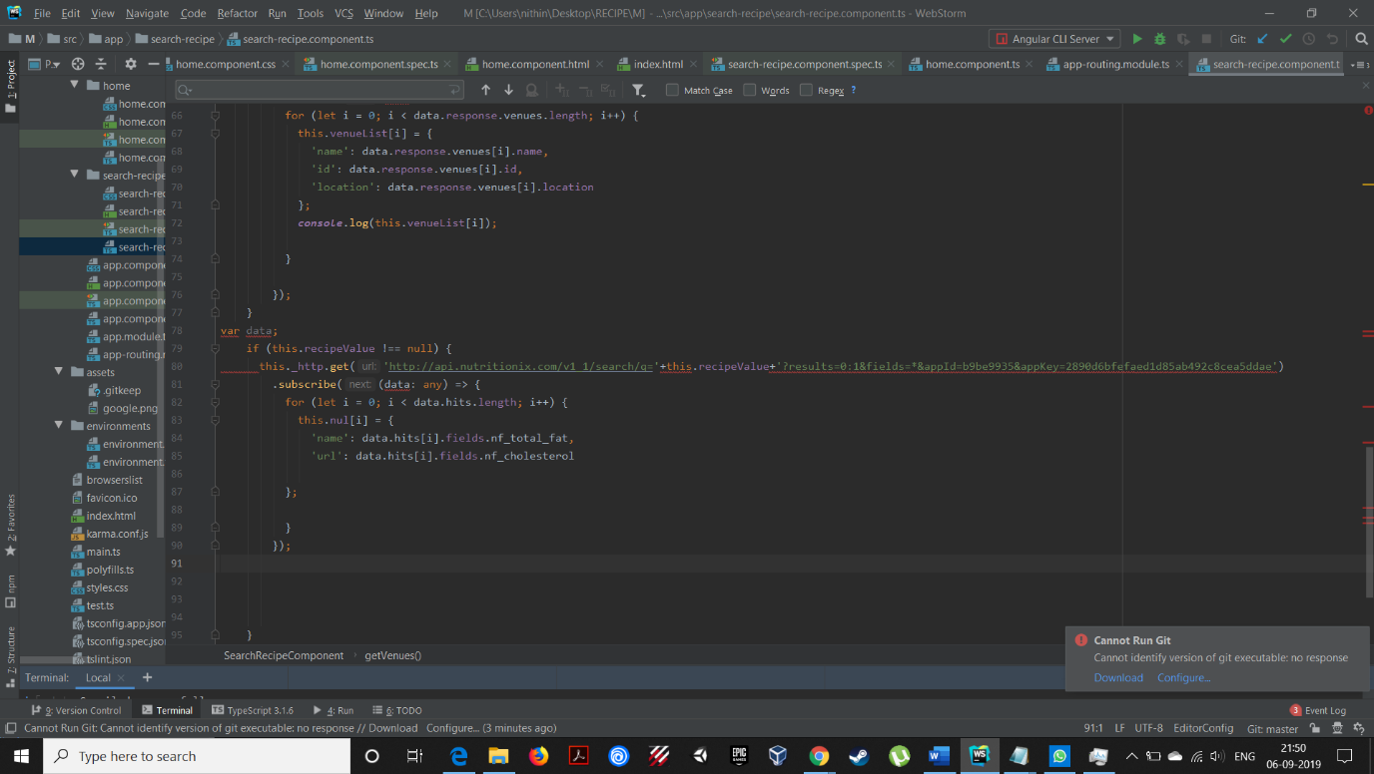

This is the code for collecting the data from API and pushing the values to the nutrition box.

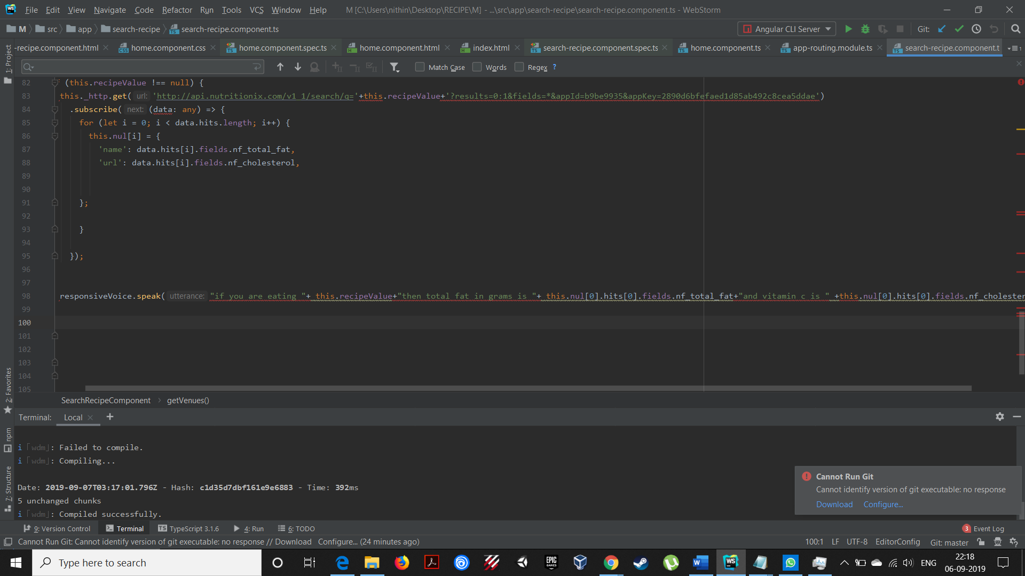

The below statement is given to read out the speech using the responsive Speech API.

**Contribution:**

Both of us worked equally inorder to get this job done

**by**

**Dukkipati, Sri Sai Nithin Chowdary(class id 05)**

**Skoglund, Rod (class id 23)**